16 – BIT SUBTRACTION

# EXP NO:06

# AIM:

# To Write an assembly language program to implement 16-Bit Subtraction using 8086 processor.

# 

# ALGORITHM:

1. Start the program by loading the first data into the accumulator.

2. Move the data to a register.

3. Get the second data and load it into the accumulator.

4. Subtracting the two register contents.

5. Check for subtraction

6. Store the value of difference and borrow in the memory location

7. Halt.

# 

# PROGRAM:

LHLD 8500

XCHG

LHLD 8502

MVI C,00

MOV A,E

SUB L

STA 8504

MOV A,D

SUB H

STA 8505

HLT

# INPUT:

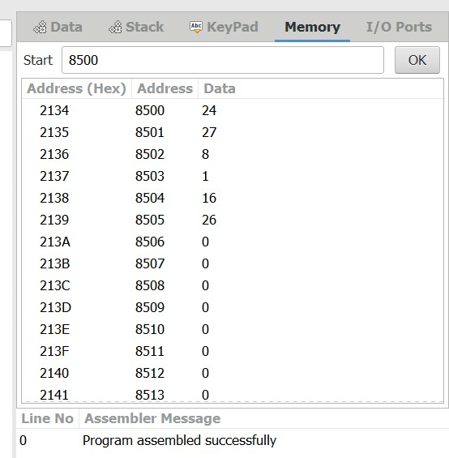

# OUTPUT:

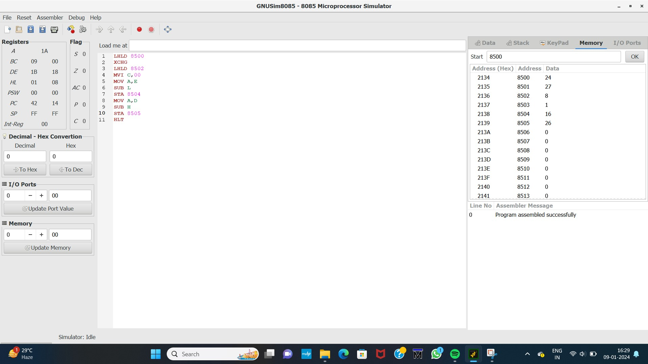

# RESULT:

Thus the program was executed successfully using 8086 processor stimulator.